Sean Parrell

R Assignment 4

Exercise

This exercise evaluates the difference in vital capacity between brass players and a control group. Data was collected to determine if brass players have a higher vital capacity than non-brass players. Below are the steps for analyzing the data and performing hypothesis tests.

Step 1 - Reshape Data to Long Format

The data is transformed to a "long format" data frame with columns Vital and Group:

Code for R I used:

data <- data.frame( Vital = c(4.7, 4.6, 4.3, 4.5, 5.5, 4.9, 5.3, 4.2, 4.7, 5.1, 4.7, 5.0), Group = factor(c(rep("Brass", 7), rep("Control", 5))) )

Step 2 - Conduct a t-test (Two-Sample) Without Assuming Equal Variance

Using the t.test function with formula format, we test if the mean vital capacity of brass players is statistically higher than the control group.

Code for R I used:

t_test_result <- t.test(Vital ~ Group, data = data, alternative = "greater")

t_test_result

Screenshot from R of my code and results made:

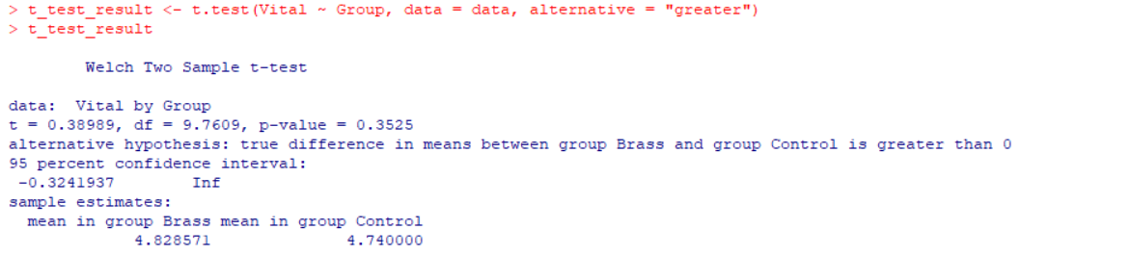

Step 3 - 95% Confidence Interval for Difference in Population Means

Since a one-sided hypothesis test was conducted, the equivalent one-sided 95% confidence interval is extracted directly from the t.test output.

Code for R I used:

t_test_result$conf.int

Screenshot from R of my code and results made:

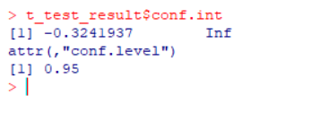

Step 4 - Repeat t-test Assuming Equal Variance

Under the researcher’s assumption that the variance between groups is equal, we repeat the test using var.equal = TRUE:

Code for R I used:

t_test_equal_var <- t.test(Vital ~ Group, data = data, alternative = "greater", var.equal = TRUE)

t_test_equal_var

Screenshot from R of my code and results made:

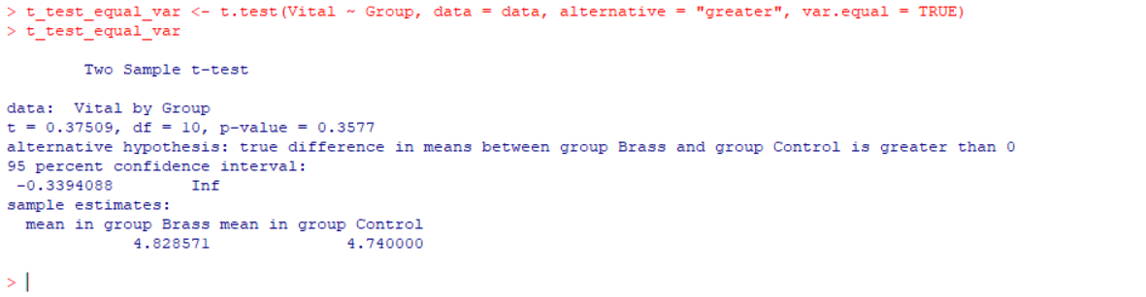

Here is a screenshot of the whole R page with all this code:

